

Smart power supply v2.0

A Smart power supply using ATmega32A Microcontroller capable of just about anything.



September 18, 2024

Basel Mohamed Mostafa Sayed

# SPS v2.0 details:

1. 120W+ Linear Power Supply.
2. Has two charging ports, one for normal speeds (5W) and the other for high-speed charging (37W).

* The 5W charging circuit will be current limited to 1A using the L7805 regulator.
* The 37W charging circuit will be using the LM2596 step-down voltage regulator.

1. Has two output voltage modes,

* The first is a positive only High ampere output capable of delivering full power at 7A peak.
* Using the LM338T voltage regulator
* The second is a positive AND negative medium (1.5A) output capable of everyday electronic testing.
* Using LM317T and LM337T for both positive and negative voltages respectively.

1. Has a charging port for 18650 batteries.
2. Has a charging port for Lithium-ion batteries using the TP4056 battery charging module.
3. PWM fan control using the L293D motor driver as PWM controller and Fan motor connection, and 12V regulator L7812 and IRF540N.

All of this will be controlled using the ATmega32A microcontroller.

* All the outputs will be controlled via relays or high power MOSFETS, each output will be a function that YOU (The user) execute via a menu that appears on the LCD.
* Voltage reading will be via voltage dividers.
* A diagram of a temperature sensor

  Description automatically generatedCurrent reading will be using the ACS712 current sensor module (up to 20A).

## Explaining each function with detail:

In this section, I will explain to you each function that the SPS (Smart Power Supply) V2.0 is capable of and providing circuit schematic and connection explanations.

### 1) The main two outputs of the SPS v2.0:

🡪In here I will explain the main two outputs.

#### A black and silver transistor Description automatically generatedThe first being the HIGH ampere output with full power.

🡪I will be using the LM338T, which is an excellent voltage regulator capable of delivering a MAX 5A load with 32V which will be more than enough to power most DC motors and high-powered components.

* Using the ATmega32’s PWM output (TMR0) as a driver for a MOSFET (NMOS) to efficiently and effectively control the output voltage.
* The MOSFET I am using is going to be IRLZ44N – NMOS, which for this use case is going to be more than sufficient in controlling the voltage output via PWM from the ATmega32A.

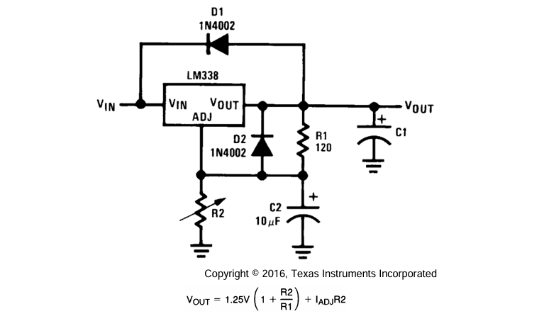For the LM338T, we’re going to connect it using the figure given in the datasheet and since stated in the datasheet for outputs more than 24V we need protections diodes, so we’re going to use protection diodes.

For maximum output voltage which in the case of our smart power supply’s transformer

$\sqrt{2}⋅24=33.9≈34V$ so, with this output in mind, we use the equation given by the datasheet to achieve maximum output.

$34=1.25\left(1+\frac{R_{2}}{220}\right)$ So then $R_{2}=5984≈6kΩ$.

So, for this configuration a variable resistor of 8K would do, but since there are no 8K potentiometer we can use the nearest value which would be 10K.

🡪Where the ATmega32A via user input using the menu on the LCD, sends a signal to the Relay controlling the output and sends it to the current sensor ACS712 and prints the voltage output and current measured on the LCD screen.

Here is the Final working simulation of the High-power output circuit:

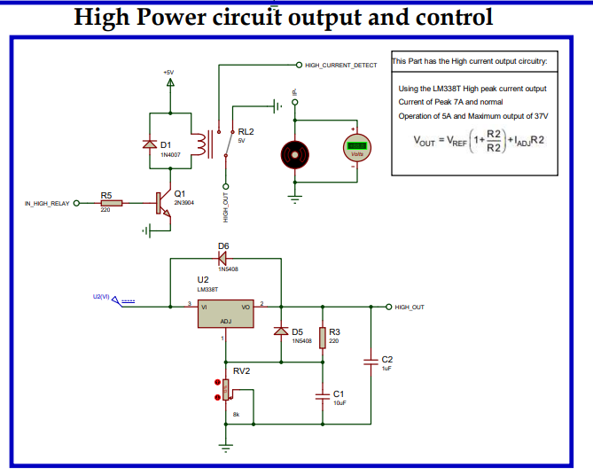

Here is the output voltage & current being measured by the ATmega32A and printed on the LCD screen:

#### The second being the Positive & Negative low output circuit:

🡪In this mode, I will stick to the tried and true positive and negative voltage regulators.

* The LM317T and the LM337T.
* Both offer the same Ampere output and will do greatly at just about testing everyday electronic components that don’t require much power unlike the LM338T.

Similarly, I am going to be using a PWM control signal to efficiently and effectively create a drive signal for the NMOS connected to the Low output.

Circuit for LM317T & LM337T:

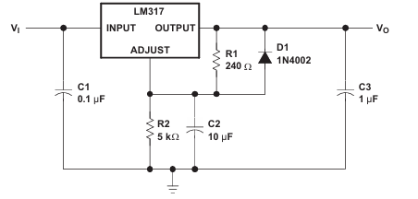In this circuit, we have improved ripple rejection (increase signal output stability) by adding the capacitors at the input and C2 at the ADJ pin, similarly Diode D1 exists as protection in case the output is shorted to ground.

* The LM317T and LM337T follows the same formula as the LM338T so the circuit values are going to be the same as above and again, we will use the same 10K ohm potentiometer.

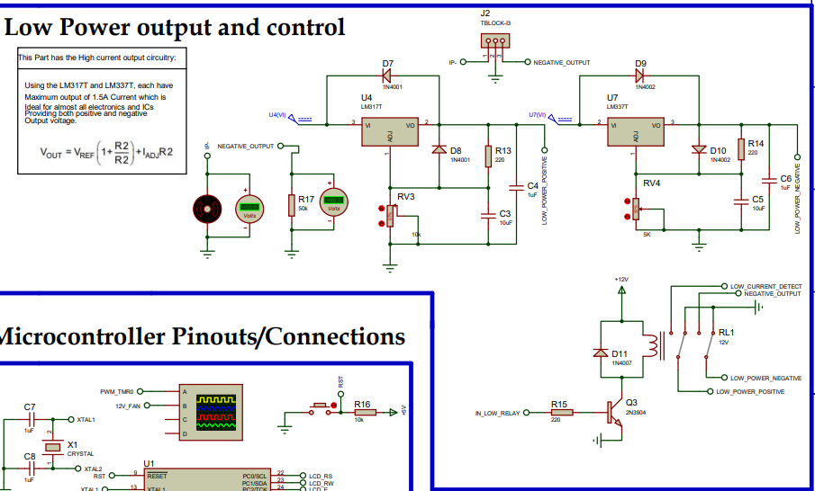

🡪In the circuit above, we have the connections for the LM317T and LM337T with one signal that is controlled by the ATmega32A where once again like the High-power circuit, the voltage and current are measured and printed on the screen.

### 2) Charging circuits:

🡪The charging circuits for the USB output ports are simple enough to charge most phones and power most USB powered electronic devices.

To enable the Charging circuit outputs, the user chooses mode 3 in the LCD screen menu which sends a signal via the ATmega32A to the Relay controlling the Charging circuits and also sends power to the Lithium Battery Charger and 18650 Battery charger.

#### Slow Charging circuit:

* The 5W-7.5W circuit is meant to be used to power low power electronics via USB output or charge old phones, and smartwatches.
* 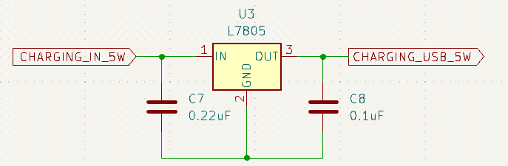The Circuit is going to be built using the simple regulator L7805, where 5V is the target output voltage.

#### Fast Charging circuit:

* This circuit is going to use the LM2596 – ADJ regulator.

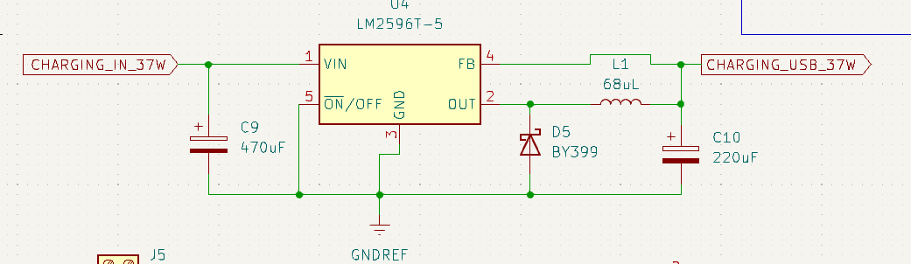

All the values are chosen according to the datasheet to provide the highest stable output voltage with low voltage ripple.

#### TP4056 Lithium battery charger:

🡪There is another output charging signal that is sent by the ATmega32A controller when the user chooses Charging mode, that activates the Lithium Battery Charger and the 18650-battery charging.

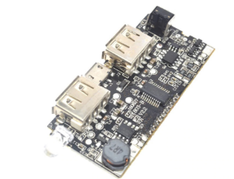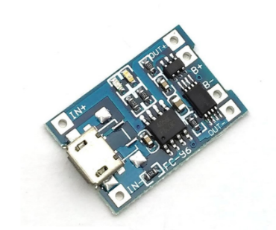

1. TP4056 module.
2. Using a 15W battery bank charger module to charge the 18650 batteries.

🡪I have decided to exclude this mode for the time being just because there is no simulation for them in proteus but in real life it could be easily added and in fact, already coded into the ATmega32A.

### 3) Frequency Counter:

The Frequency Counter is implemented using the Timer 1 “Input Capture Unit” in the ATmega32A by setting the appropriate mode and using the Timer 1 driver, I achieved a 0-50V input range and maximum of 1MHZ frequency that could be read.

* This mode also gives the user complete access to choose and change the Prescaler to be used by the Timer 1, which gives the user much more control over the mode and allows for a very diverse and wide selection of signals to be read.

By choosing this mode, the user is prompted with a menu to choose the Prescaler to use:

* 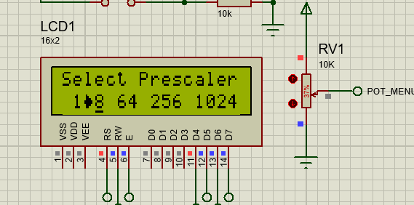By moving the potentiometer, the user can change the Arrow cursor.

## Smart Power Supply case design using Fusion 360:

🡪I also modeled a 3D printable case for the PSU using fusion 360.

* The case houses all the internal components for the Smart Power Supply and the appropriate cut-outs for the LCD screen, menu buttons and whatnot.

External Case front face and side, showing the menu buttons, LCD screen and output banana plugs with the top having a 120mm fan mounted and to the side we have battery 18650 charging:

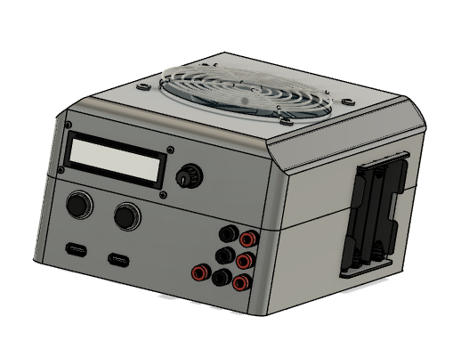

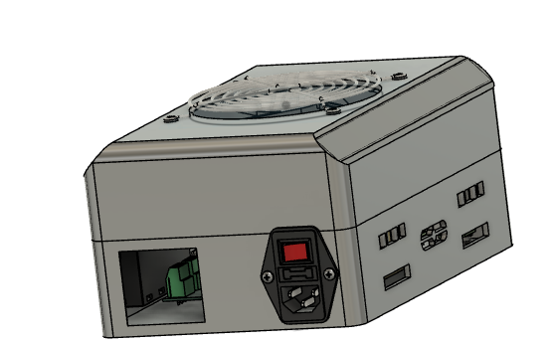Where in the back we have the Power AC input with fuse and switch mount and we also have a cut hole for ventilation and in the other side, we have more ventilation holes.